**PROMETHEUS:**

**DevOps - Monitoring Tool: Prometheus and Grafana:**

**1. Purpose: Proactive Monitoring + Dashboard Generation + Alerting**

**2. Metrics: Application, Logs, Disk, Network, Database, Security, Server etc**

**3. Prometheus is for Server Monitoring - Monitors n no of metrics – Scrape time Min 15secs to 1min. Evaluation Time and Default Timeout.**

**4. AWS Service - Cloudwatch Monitoring - Monitors Infrastructure - upto 21 metrcis with min 60secs intervel**

**5. Functionality:**

**Prometheus Server Monitors Multiple Ec2 servers**

**Deticated Server Node Exporter should be installed in Server to be monitored**

**Master Server Pull based mechanism**

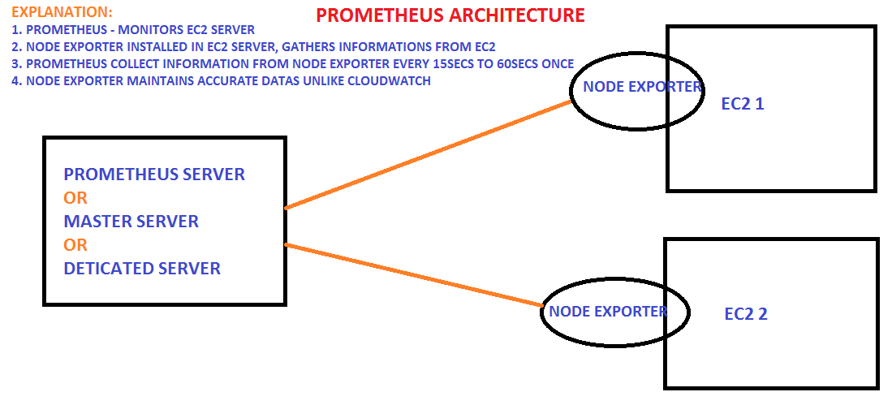

**At the same time Prometheus would collect the Informations about the server from**

**the Node Exporter for the each servers**

**Mechanism - Pull Based Mechanism**

**Able to maintain the accurate datas**

**6. TSDB - Time Series DataBase - No need to store datas everytime ... and only we need to**

**record the differences of each days**

**7. Architecture: Retrieval ===>> TSTB ===>> HTTP Request**

**PROMETHEUS:**

# Create two Ubuntu/Linux servers and login and also become a root user and And open all tcp: cd /opt

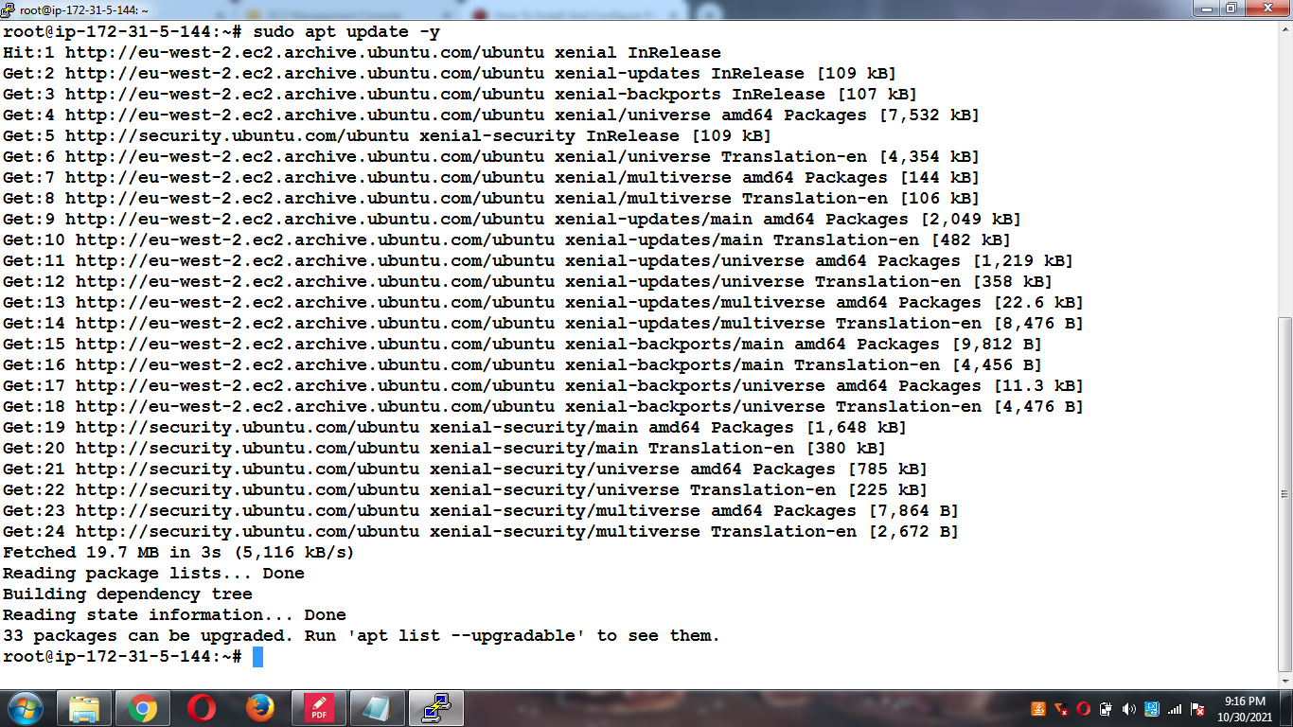

**wget** [**https://github.com/prometheus/prometheus/releases/download/v2.22.0/prometheus-2.22.0.linux-amd64.tar.gz**](https://github.com/prometheus/prometheus/releases/download/v2.22.0/prometheus-2.22.0.linux-amd64.tar.gz)

**t**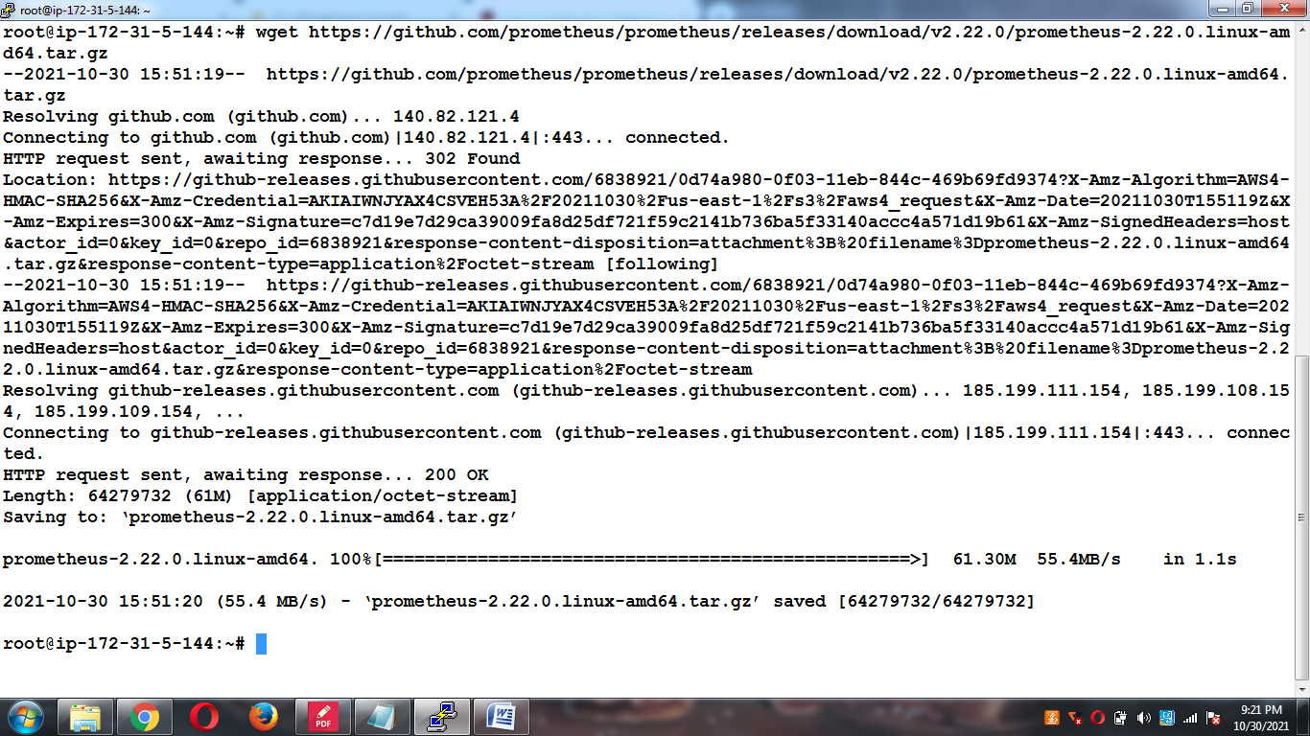

**Verify the Prometheus**

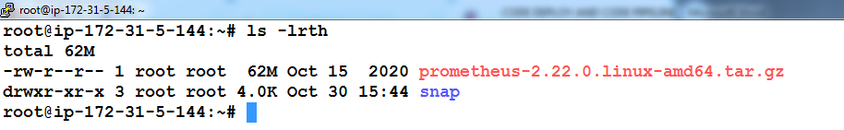

**Verify the Prometheus**

**tar -xvf prometheus-2.22.0.linux-amd64.tar.gz**

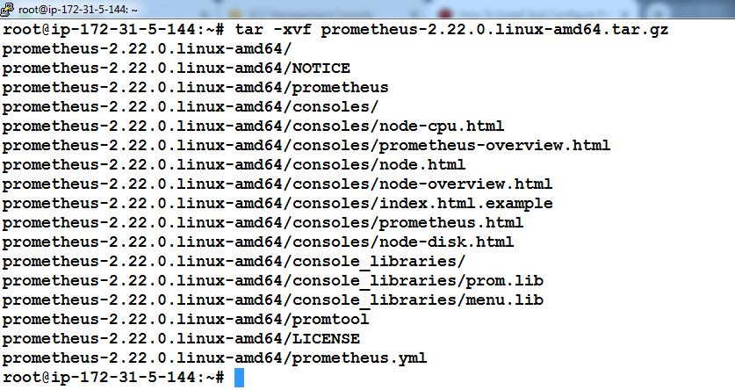

**Navigate to prometheus and copy prometheus and promtool to /usr/local/bin**

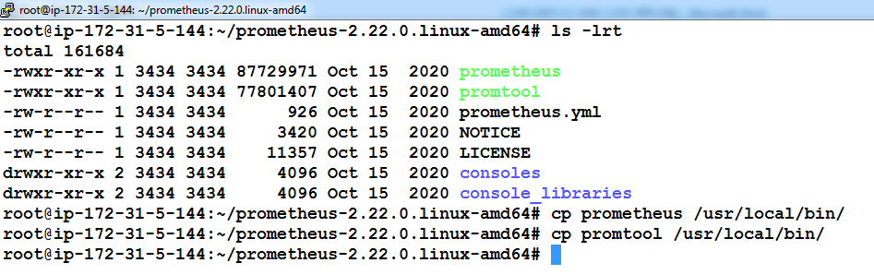

**Start prometheus process using**

**./prometheus --config.file=prometheus.yml &**

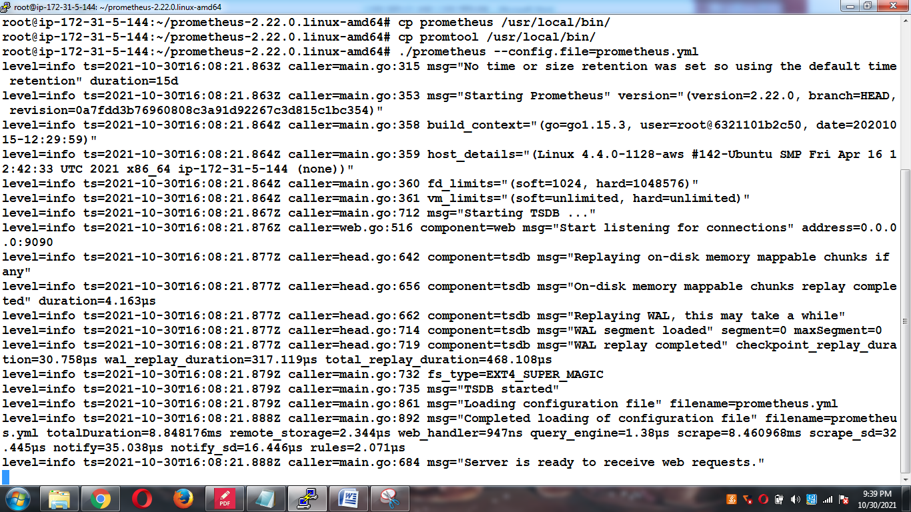

**Verify using the Prometheus with ip and port number**

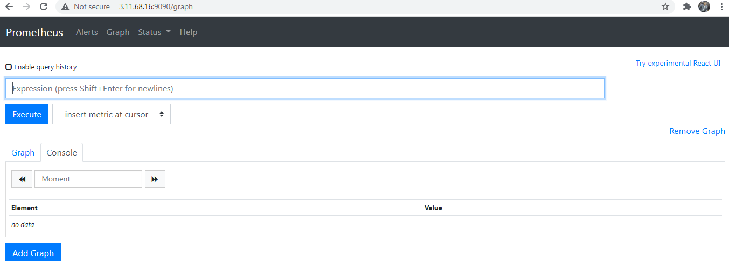

**Check the metrics of the Server or Host**

[**http://3.11.68.16:9090/metrics**](http://3.11.68.16:9090/metrics)

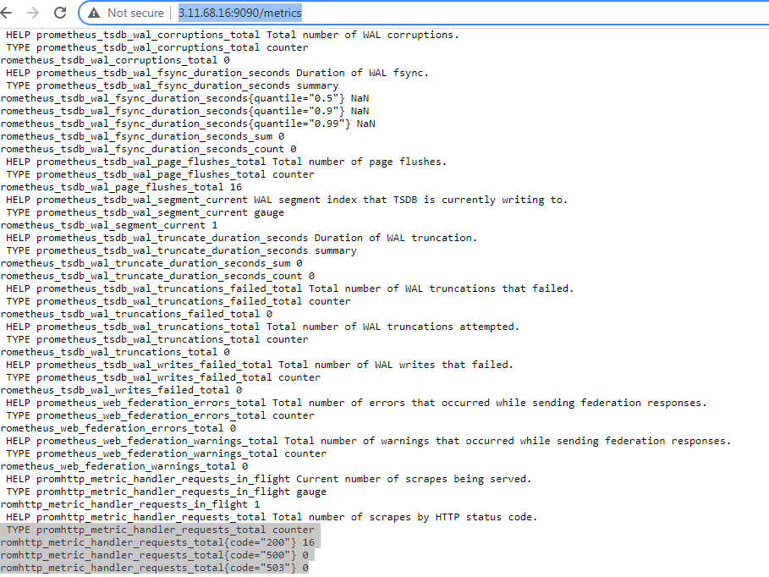

**Intallation of the Node Exporter**

**Login and Become a root user**

**Navigate to Node Exporter**

[**https://rm-rf.medium.com/install-node-exporter-for-prometheus-grafana-d0ec29b8a2b6**](https://rm-rf.medium.com/install-node-exporter-for-prometheus-grafana-d0ec29b8a2b6)

**wget** [**https://github.com/prometheus/node_exporter/releases/download/v1.2.2/node_exporter-1.2.2.linux-amd64.tar.gz**](https://github.com/prometheus/node_exporter/releases/download/v1.2.2/node_exporter-1.2.2.linux-amd64.tar.gz)

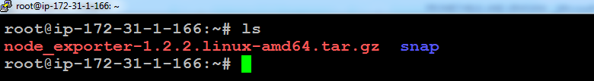

**Extract the downloaded archive**

**tar -xvzf node_exporter-1.2.2.linux-amd64.tar.gz**

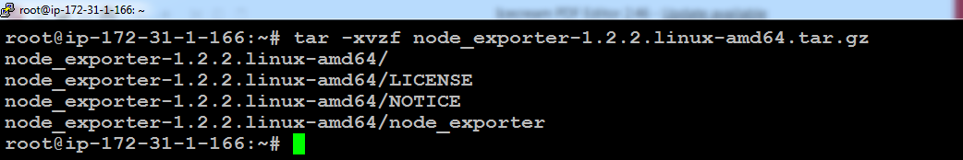

**Navigate to the Node Exporter**

**cd node_exporter-1.2.2.linux-amd64/**

**./node_exporter &**

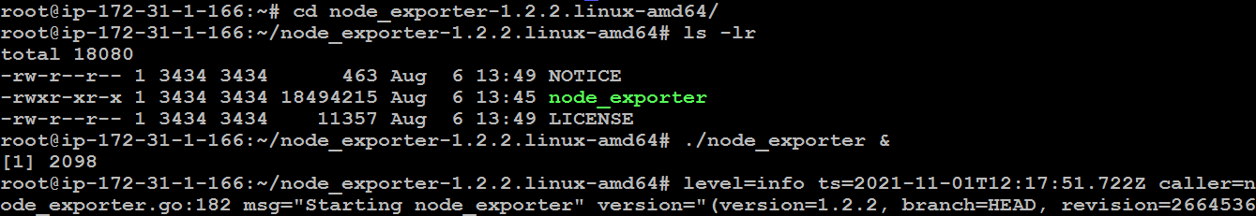

**Node_Exporter Loading=> ublic ip:9100**

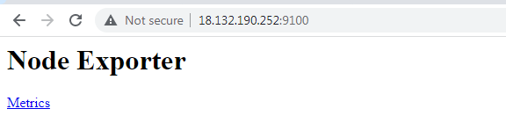

**Check the Node_Exporter Metrics:**

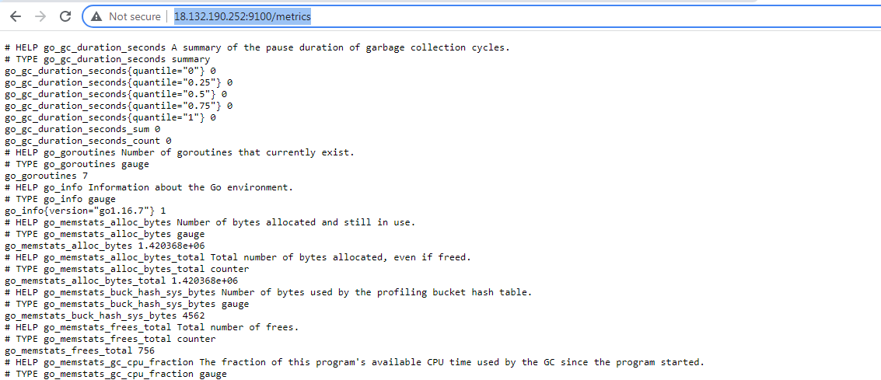

**Map Node Exporter Server to Prometheus server:**

**Enable to fetch the metrics under the prometheus UI**

**Goto Prometheus server and navigate to the following FS:**

**root@ip-172-31-12-182:~/prometheus-2.22.0.linux-amd64# vi prometheus.yml**

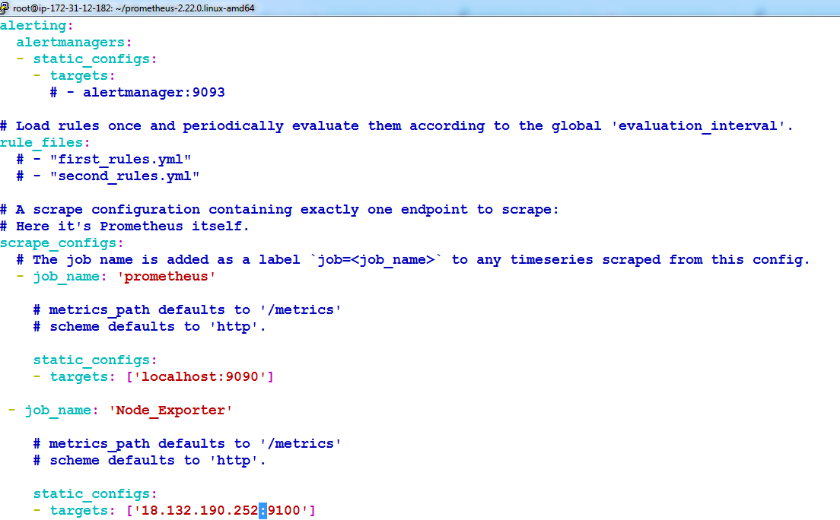

**- job_name: 'Node_Exporter'**

**# metrics_path defaults to '/metrics'**

**# scheme defaults to 'http'.**

**static_configs:**

**- targets: ['localhost:9100']**

**Stop the Prometheus process by kiiling on the same:**

**Kill the process id 2298:**

**ps –ef | grep prometheus**

**kill -9 2298**

**./prometheus –config.file prometheus.yml &**

**ps –ef | grep prometheus**

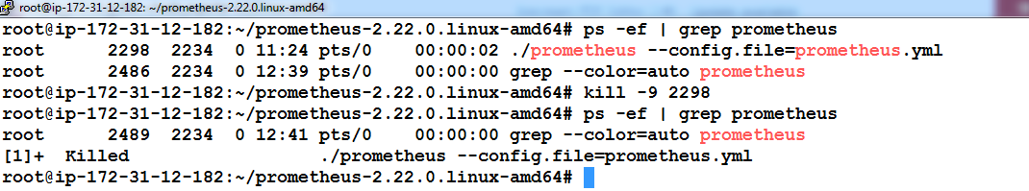

**Verification:**

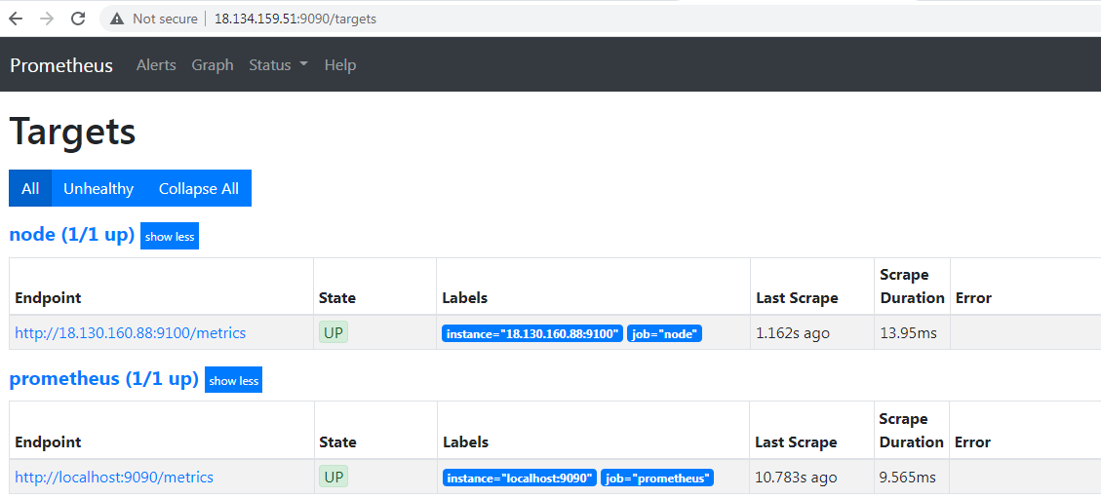

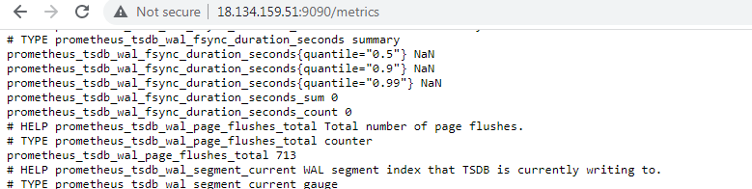

**Drawback: Authentication + Visualization**

1. **There is no Authentication & Time out also happens since we access prometheus directly**
2. **There is no Proper Visualization in Prometheus**
3. **To Enhance good Visualization and Grafana could be inistalled on Prometheus Server**
4. **Grafana could extract the server information from the prometheus and also it monitors both Prometheus and Node.**

**Download Grafana Tool and start:**

[**https://grafana.com/grafana/download/8.1.0?edition=oss&platform=linux**](https://grafana.com/grafana/download/8.1.0?edition=oss&platform=linux)

**wget** [**https://dl.grafana.com/oss/release/grafana-8.1.0.linux-amd64.tar.gz**](https://dl.grafana.com/oss/release/grafana-8.1.0.linux-amd64.tar.gz)

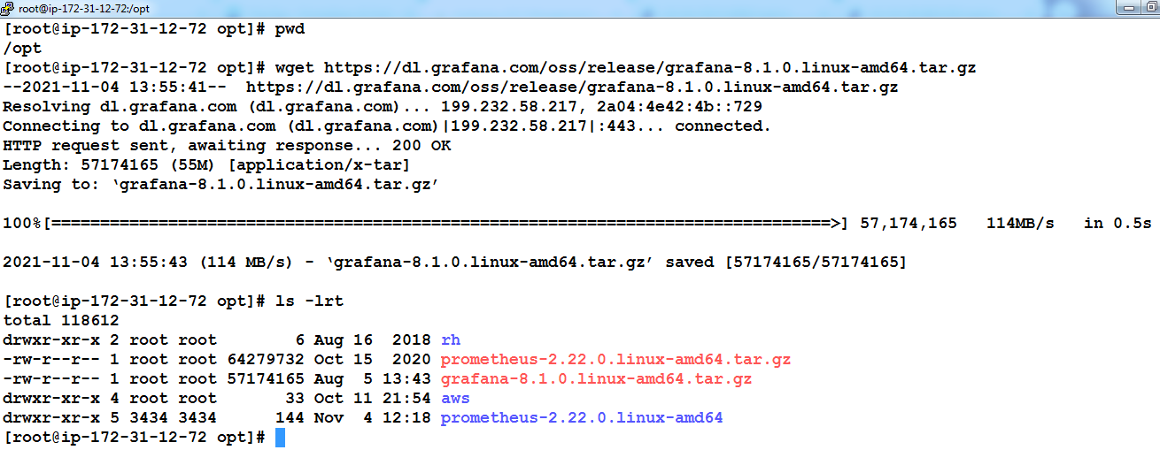

**tar -zxvf grafana-8.1.0.linux-amd64.tar.gz**

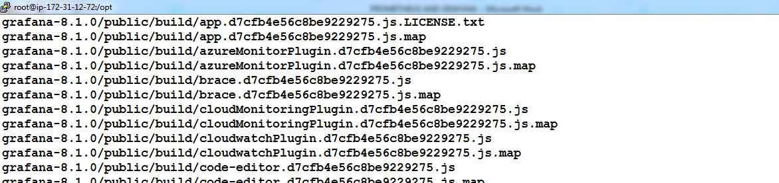

**./grafana-server &**

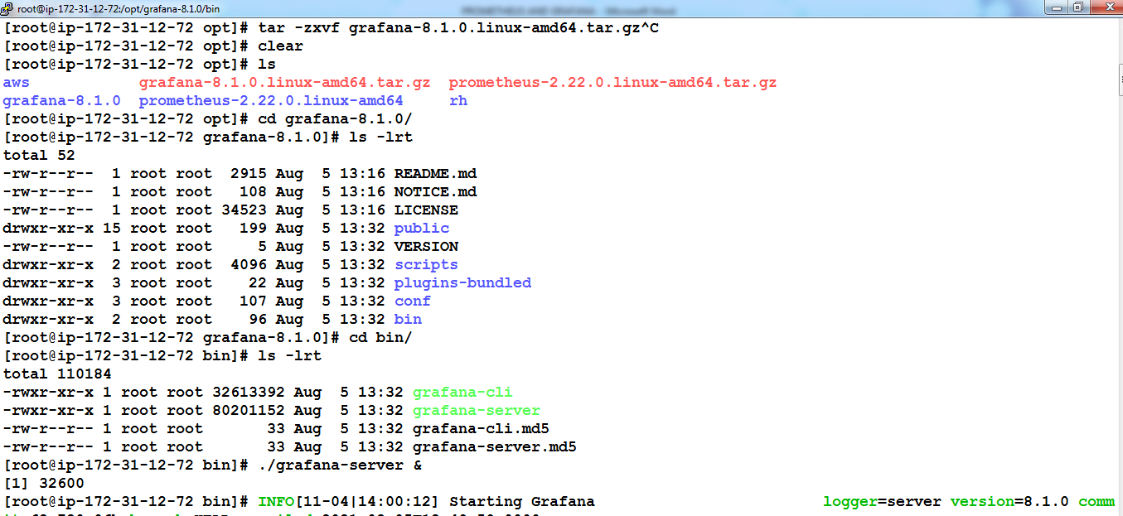

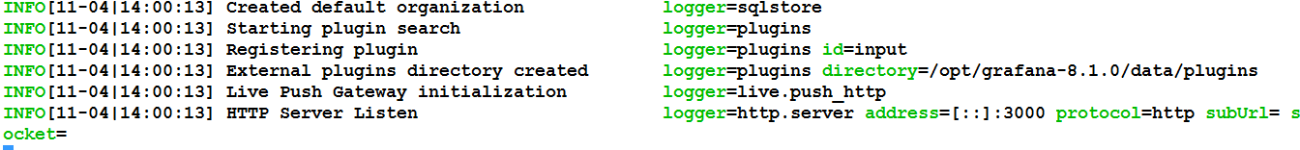

**Login Grafana: using admin and admin:**

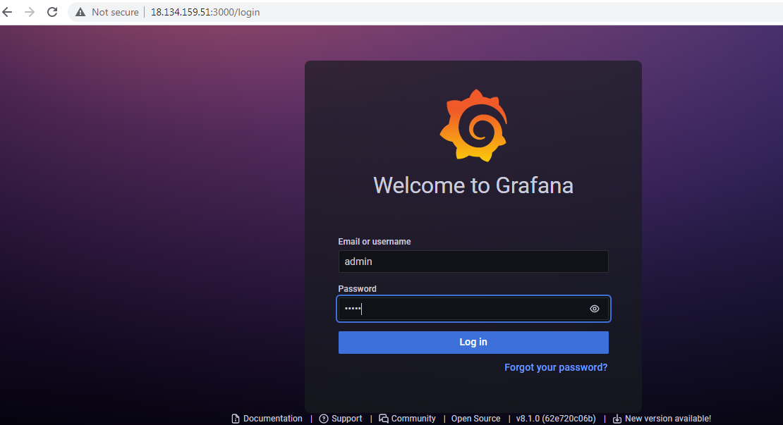

**Change the Password:**

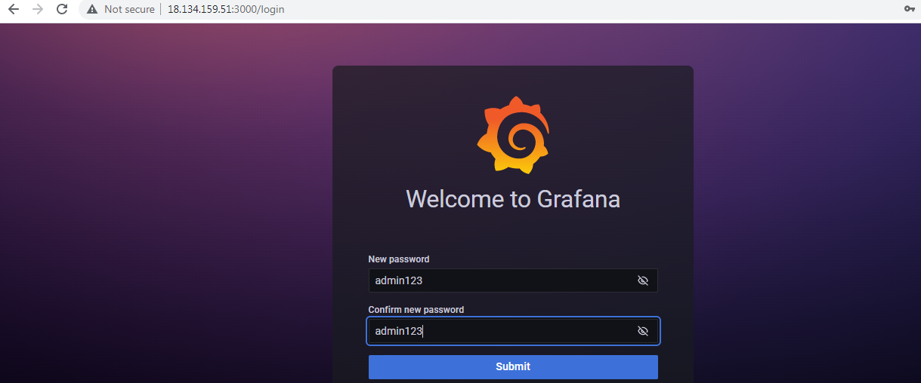

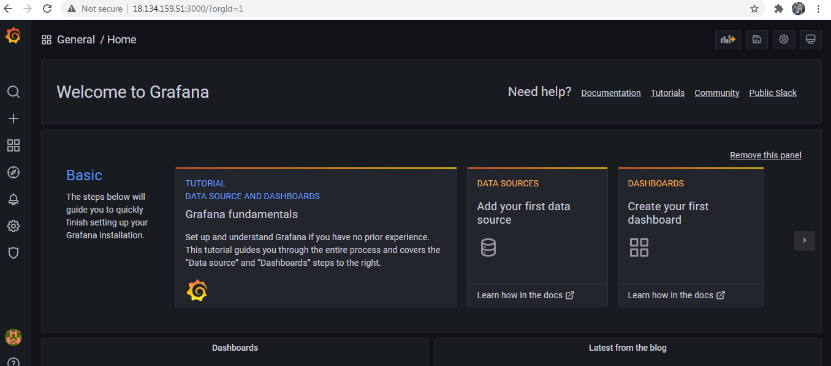

**Goto Configuration and add data sources:**

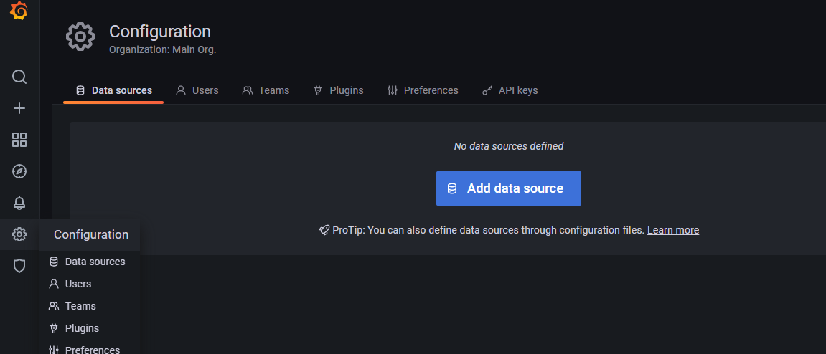

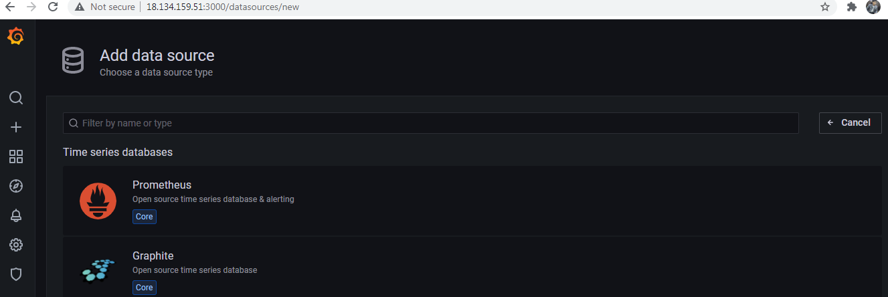

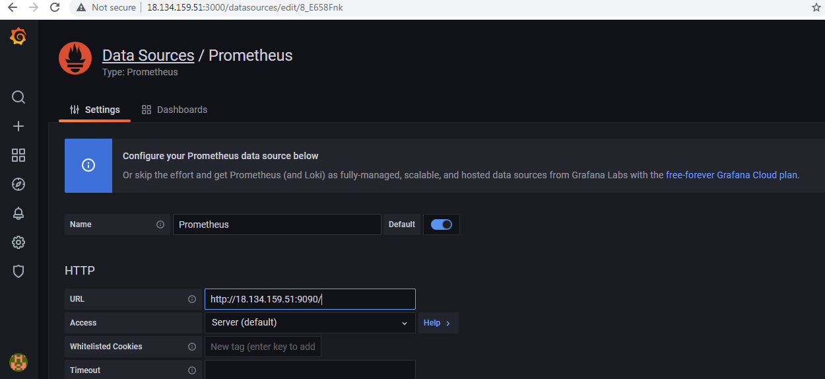

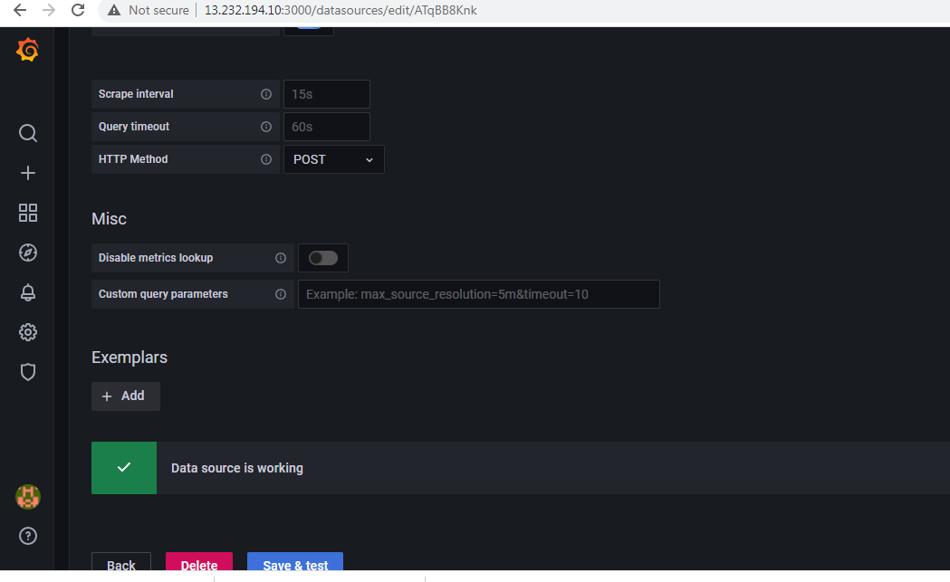

**Import new dashboard view**

[**https://grafana.com/grafana/dashboards/13978?pg=dashboards&plcmt=featured-dashboard-2**](https://grafana.com/grafana/dashboards/13978?pg=dashboards&plcmt=featured-dashboard-2)

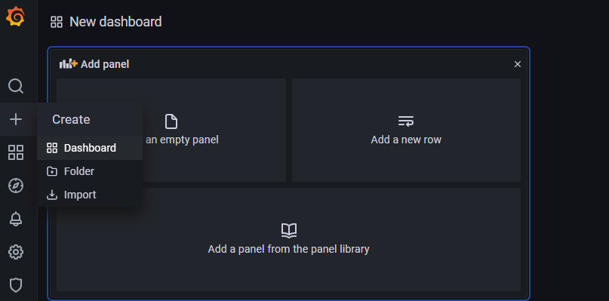

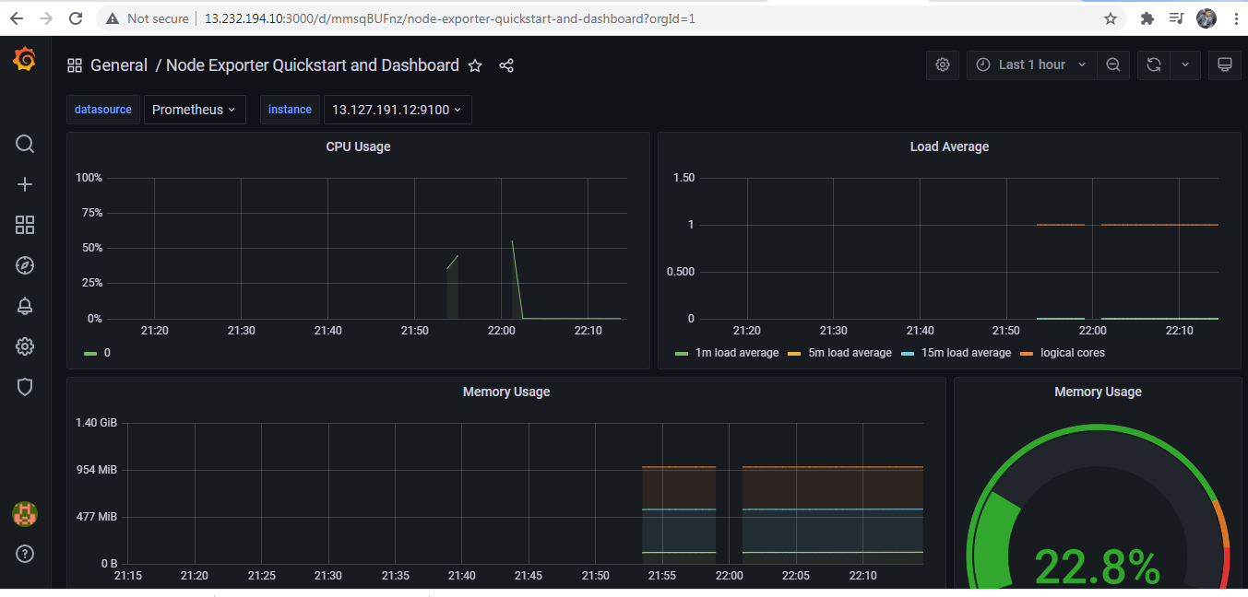

**DEMOLISH:**

**EC2 SERVER DELETION**

**1. Prometheus - Infrastructure or Server monitoring tool - 9090**

**2. Is this require Prometheus to be installed on top of Slave machine? No**

**3. What is the Mechanism used? Pull mechanism**

**4. What is scrape time? min and max? - prometheus to node Exporter hitting time interval**

**15secs and max 60secs**

**5. What is the Evaluated time? - 15secs to 1min**

**6. Evaluation time out? 10Secs**

**7. Job name and Local Host - Initially its monitor prometheus server**

**Slave - Job name: node; localhost: 'ip:9100'**

**8. restart / reboot - prometheus.yml - process id kill and ./prometheus --config.file=prometheus.yml &**

**9. Default port no for Grafana? 3000; We install in prometheus server.**

**10. Drawback on prometheus? Visualization is not proper, No Authentication, timeout**

**11. Grafana? - Source Prometheus**

**12. Alerting Enable? yes**

**13. new Dashboard? yes**

**14. Node_exporter? 1005**

**15. prometheus? 819**

**16. aws cloudwatch - 21 metrics; 60Secs**

**17. Grafana - prometheus + Node**

**18. RCA - Root cause Analysis; CSI - Continual service improvement.**

**19. key-metrics: CPU/MEMORY/DISK/NETWORK**